**Java Singly Linked List**

**Main Menu:**

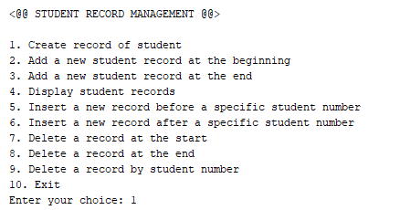

**Create**:

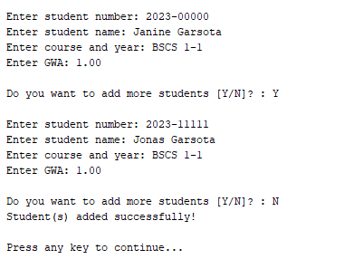

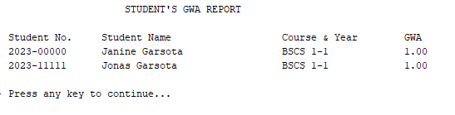

**Add at Beginning**

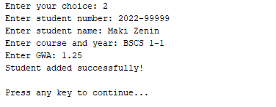

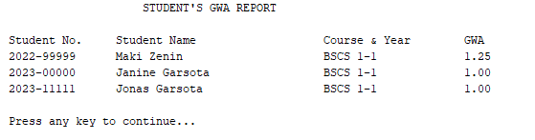

**Add at End**

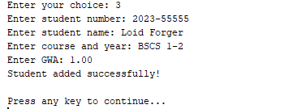

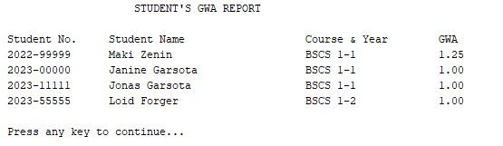

**Insert a new record before a specific student number**

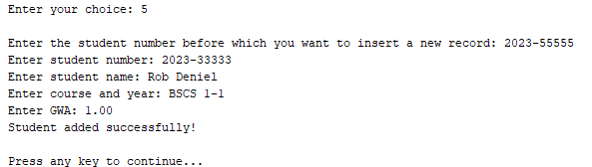

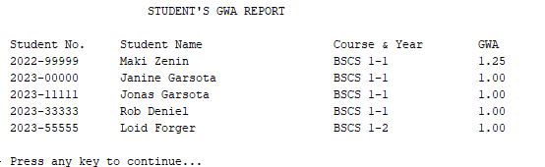

*(if not found)*

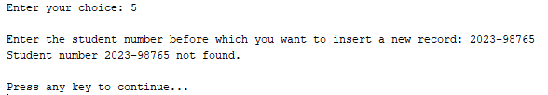

**Insert a new record after a specific student number**

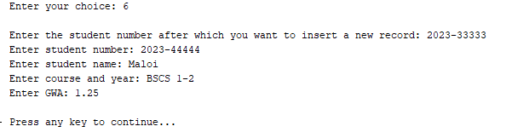

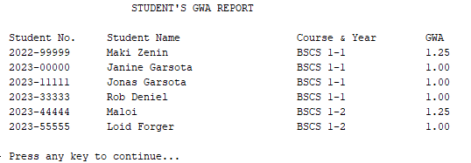

*(if not found)*

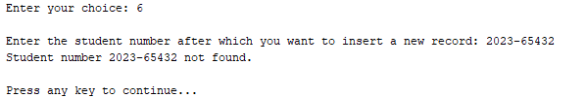

**Delete a record at the start**



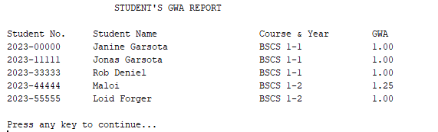

*(if empty list)*

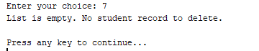

**Delete a record at the end**

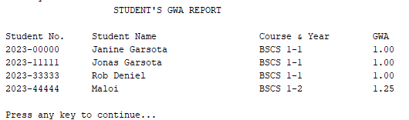

*(if empty list)*

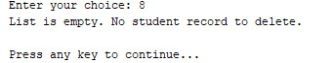

**Delete a record by student number**

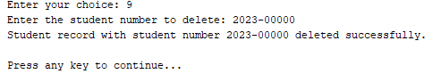

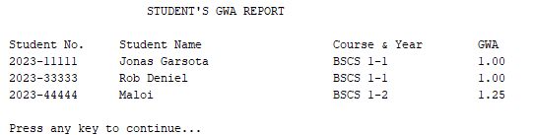

*(If not found)*

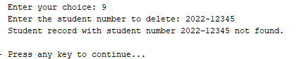

**Exit**

